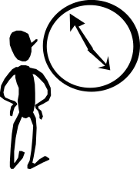 The Linux time command
Returns the time in seconds that a program runs

Note : Run is an executable piece of software being used to sort all input data using a
selection sort. It is an O(n²) algorithm.

Adata input file has an n = 10,000. Bdata input file has an n = 100,000.

[digh_a@cobra Run]$ time java Run < Adata

real 0m1.059s
user 0m1.060s
sys 0m0.000s

[digh_a@cobra Run]$ time java Run < Bdata

real 1m45.456s
user 1m45.380s
sys 0m0.020s

